18.89: a) A positive slope 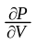 would mean that an increase in pressure causes an increase in volume, or that decreasing volume results in a decrease in pressure, which cannot be the case for any real gas. b) See Fig. (18.5). From part (a), cannot have a positive slope along an isotherm, and so can have no extremes (maxima or minima) along an isotherm. When 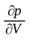vanishes along an isotherm, the point on the curve in a 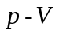 diagram must be an inflection point, and 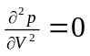

c) 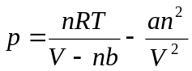

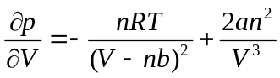

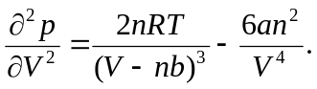

Setting the last two of these equal to zero gives

- Following the hint, 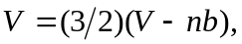 which is solved for 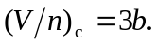 Substituting this into either of the last two expressions in part (c) gives 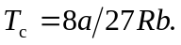

- 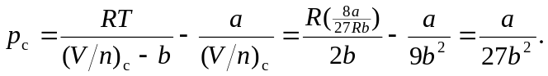

- 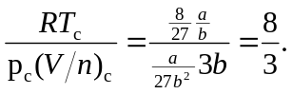

g) 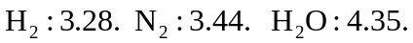 h) While all are close to 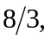 the agreement is not good enough to be useful in predicting critical point data. The van der Waals equation models certain gases, and is not accurate for substances near critical points.

